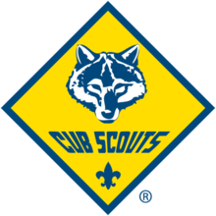

See Where Scouting Takes You.
Pack ____Parent Information Guide
Welcome to the Adventure of Cub Scouting!
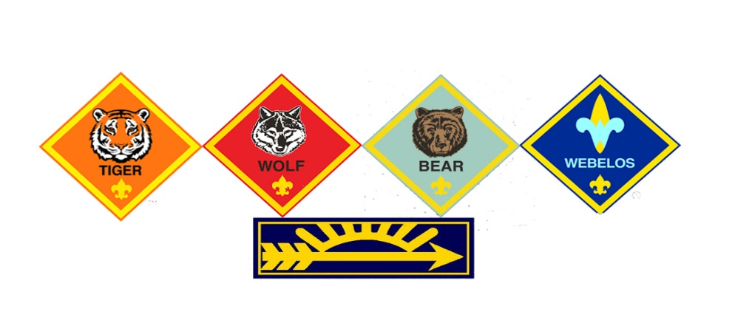
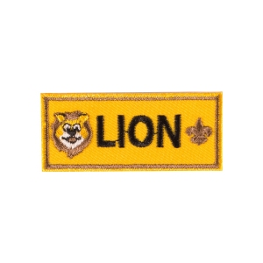


Parent Handbook
Cub Scout Pack

Welcome to Cub Scouts and Pack 103!
Welcome to Cub Scouting, part of the Boy Scouts of America (BSA). We are Pack XXX and we have approximately xx Cub Scouts and their families from cityxxx and the local area that actively participate in our program. We welcome both Boys and Girls Kindergarten through 5th grade.

As with any program, you will get out of the program what you put into the program. We know there is a lot of information to absorb, so we have compiled the basic information you will need into this handbook. We also have a website that will provide you with up-to-the-minute information regarding events, points of contact, and just about any other scouting information you might need.

We are glad you chose to join our Pack and look forward to watching your young scout grow and develop as an individual, as a family member, and as a citizen and leader in the community. Now let’s have some fun!!!!!
Website: (your website here)
Contents
Why Join Cub Scouting? 3
How is Cub Scouting Organized? 4
Dens 5
Den Meetings 5
Girl and Boy Dens 5
Pack 6
Pack Meetings 6
Pack Activities 6
The Pack Committee (group of parent volunteers) 6
Scoutbook……………………………………………………………………………………………………………………………………………6
Scouting Beyond the Pack 7
Lake Minnetonka District 7
Northern Star Scouting 7
Pack Calendar 8
My Involvement as a Parent 9
Learning about my Role 10
Uniform and Books 11
Sewing Uniform Patches 12
Key Information for my Scout 13

Why Join Cub Scouting?

Your time is valuable. More than ever, today's families struggle to find time to spend together. Cub Scouting helps to support your family by providing ready-made opportunities for you and your child to do together.

Make memories with your child that will last a lifetime.

Your child needs to belong to a group of children their own age. Through this sense of belonging, they build self-esteem and learn to get along with others. As a parent, you want to be assured that the groups your child joins will teach values consistent with good citizenship, character development, and physical fitness. The Boy Scouts of America has been weaving these lifetime values into fun and educational activities since 1910.

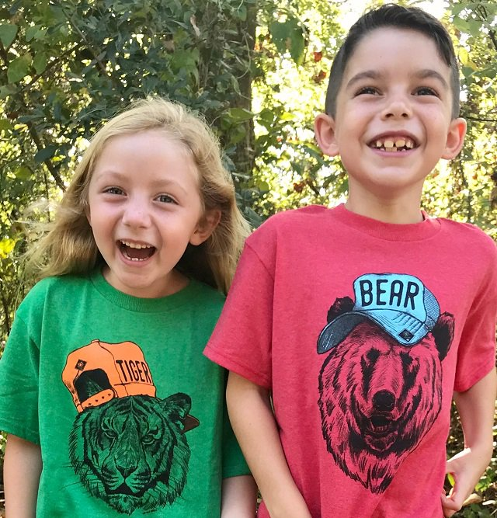
2
There are 3 key goals of Cub Scouting:

- Good Citizenship
- Positive Character Development
- Personal Fitness

Our Motto is: “Do Your Best”

Scouting teaches family values and works to strengthen your relationship with your child. We all know that children don't join Cub Scouting just to get their character built.

Children join Scouting because it is FUN!

How is Cub Scouting Organized?

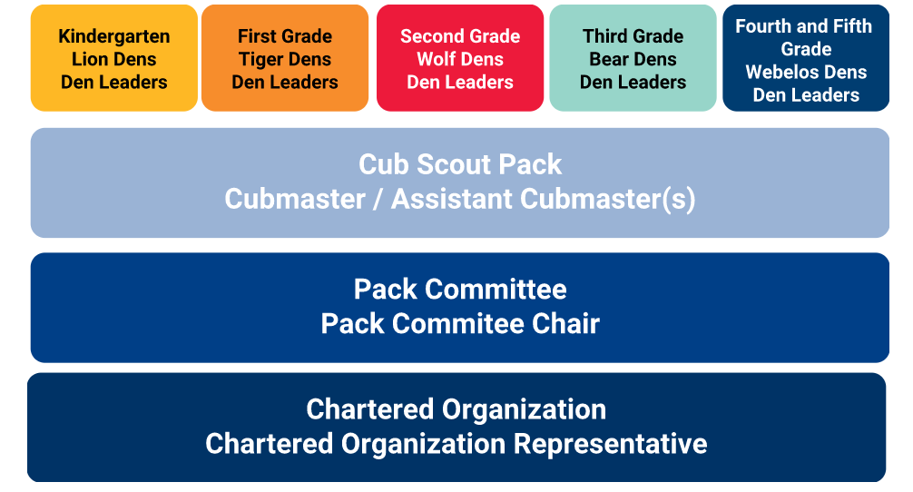
Dens  A small group of Cub Scouts who are the same gender and in the same grade. The ideal size is 6 to 8 Cub Scouts. | Pack  The pack is made up of several dens. The make up and size of the pack varies based on local interest and resources. Each pack is identified by a number. | Pack Committee  Made up of parents, leaders, and other caring adults the pack committee works to support den leaders and the cubmaster. | Chartered Organization  This is the organization that partners with the Boy Scouts of America to deliver a Scouting program. They adopt Scouting to serve the youth in the community.
Den Leaders  An adult, usually a parent, serves as a Den Leader. They carry out the activities related to adventures as they are presented in the Cub Scout’s handbook and the Den Leader Guide | Cubmaster  The leader of the pack meeting is the Cubmaster. In addition to serving as the master of ceremonies the Cubmaster provides support to Den Leaders. | Pack Committee Chair  The top volunteer in the pack is the Pack Committee Chair. They are responsible for ensuring enough qualified adult volunteers are in place to provide the program. They lead the pack committee meetings. | Chartered Organization Representative  This person appoints the Pack Committee Chair and approves all adult leaders. They provide resources from the chartered organization.

Dens
Each scout starts as a member of a Den, but is a part of a much larger network of scouts that will support their growth and development throughout their scouting adventures. Members who join Cub Scouts are assigned to a Den based upon their grade in school which defines which rank they will work towards. They need not have earned the previous rank in order to earn the next. Each of the ranks in Cub Scouting has its own requirements that are age appropriate. As a Cub Scout advances through the ranks, the requirements get more challenging, to match the new skills and abilities they have learned.

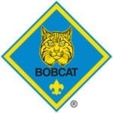 |  | First graders, and anyone beyond that grade who is new to Cub Scouting, completes the Bobcat Badge prior to working on their grade-specific badge of rank.
 |  |  | 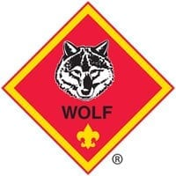 | 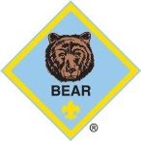 |  | 
Kindergarten  Lion | First Grade  Tiger |  | Second Grade  Wolf | Third Grade  Bear | Fourth Grade  Webelos | Fifth Grade  Arrow of Light

Den Meetings
Cub Scouts works on a school calendar year, with summer activities for the Pack. The Den typically meets monthly and is usually a group of six to ten Cub Scouts. The den allows Scouts to get to know each other better and engage in activities that would be difficult in a larger group. Each Den is led by a Den Leader who may be assisted by one or more Assistant Den Leaders and/or a Scouts BSA Den Chief. Den Leaders are trained parent volunteers. A Parent needs to attend with their Scout.

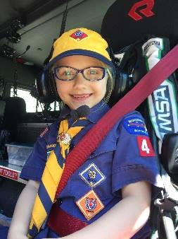
Den meeting activities are planned around the monthly theme and include games, handicrafts, hikes and other outdoor fun, practicing skits and stunts in preparation for the next Pack meeting and taking part in simple ceremonies and songs.

Girl and Boy Dens
Each Den may have both a girl and boy den, or multiple dens, for each rank. The leadership of the BSA determined that this approach builds on the proven benefits of our single-gender program, while also providing character and leadership opportunities for both boys and girls. Dens may have joint activities and all Pack meetings are for all Dens.

Pack

Pack Meetings
All Dens meet together monthly as a Pack - All Cub Scout families are invited and encouraged to attend. Pack meetings have fun programs, games, skits, stunts, songs, ceremonies and presentations of awards that the Scouts have earned that month.

The Pack meeting is the climax of the month's den meetings and activities. It gives the dens something to look forward to and work toward. This is a chance to recognize the Scouts, their parents, and their leaders. The Cubmaster (aka ‘Akela’) is an adult volunteer who serves as master of ceremonies at all Pack activities and is assisted meetings and leads Pack activities of all kinds. The Cubmaster will have an Assistant Cubmaster (aka ‘Baloo’) to help at these functions.
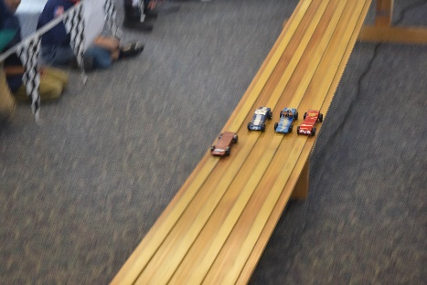

Pack Activities
In addition to its regular meetings, the Pack sponsors certain special projects. These include community projects (e.g., a Thanksgiving Food Drive for the needy), outdoor activities (e.g., field trips, family campouts, etc.), fund raising activities (e.g., fall popcorn sales), and fun competitions (e.g., Pinewood Derby).

The Pack Committee (group of parent volunteers)
Much like other community organizations you or your child are a part of, the Pack is organized and ran by a group of dedicated volunteers. The pack committee supports the den leaders and Cubmaster of the pack so they can focus on working directly with the youth in the pack. Most of these leaders are parents of Scouts in the pack. All leaders and interested parents are encouraged to attend.

- The committee meets once a month.
- The committee plans pack meetings around the monthly theme (core value).
- The committee plans events, organizes volunteers and has fun!
- The committee selects leaders, performs record keeping, manages pack finances, orders awards, maintains pack equipment, helps train leaders, and recognizes leaders.

How do I track what my Cub Scout is working on?

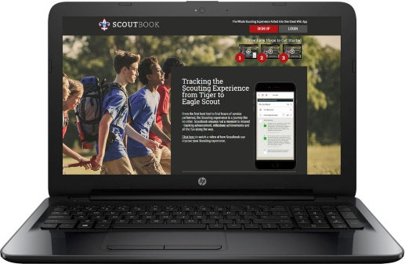

Scoutbook is a unit-management web application that is a one-stop shop for parents and unit leaders to record and manage the Cub Scouts Scouting experience. It provides a way to track advancements, unit activities through a calander as well to message the leaders in your Unit.

Scouting Beyond the Pack

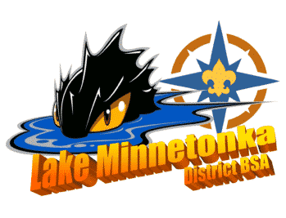
Lake Minnetonka District
http://www.lakeminnetonkadistrict.org/
To provide more localized support to scouting, councils create districts that are group together Packs, Scouts BSA Troops, and Venturing Crews in a geographic are. Districts have a volunteer District Committee that provides support to units in the areas of membership, finance, and program. In addition, our Unit Commissioner is a volunteer who works directly with the Cubmaster, Committee Chair, and Committee to guide and support our Pack. Some of the support Lake Minnetonka offers our Pack are:
- Monthly Roundtable – held on the first Thursday of each month, August – June, Roundtable offers new ideas, best practices, and great training for all leaders and parents.
- Bi-Weekly Newsletter – Get important updates, Scout activities, and updated news about Scouting delivered to you every other week. Go to http://www.lakeminnetonkadistrict.org/email-distribution-list/ and choose whether you’re a Cub Scout Parent, leader or other to get news customized to you
- Events – the District hosts different events that are open to Cub Scouts, such as camporees, ice-fishing derbies, and the District Pinewood Derby

Northern Star Scouting
https://www.northernstar.org/

To effectively support local Scouting programs the national Boy Scouts of America provides a charter to a community board of volunteers to be responsible for providing the Scouting program to a defined geographical area called councils. Councils have a volunteer board which employs a Scout Executive to serve as the CEO and give leadership to the day to day operation. The Scout Executive hires staff to provide direct and indirect support to local Scouting programs, including the professional staff who work with each Pack, Troop, and Crew in a District. In each council there are many more volunteers than staff as the organization is volunteer lead and professionally guided.

Northern Star Council operates eight (8) different council camps, with programming for all ages, from Kindergarten and up. They host two University of Scouting training session and provide numerous activities, programming, and support for our Pack. Northern Star Scouting also operates the Scout Shops where you can purchase uniforms, patches, essential items, and other gear for your Cub Scout
Main Office and Scout Shop: Peter J King Family Foundation Leadership Center, 6202 Bloomington Road, Fort Snelling, MN 55111 Phone: 612.261.2300

Plymouth Scout Shop: 10100 6th Avenue N, Ste 103, Plymouth, MN 55441 Phone: 763.417.9066

Pack Calendar
Our Pack has a number of great activities planned throughout the year for our Cub Scouts
UPDATE WITH YOUR CALENDAR

September
- Pack Meeting
- New Parent Welcome Meeting
- Popcorn launch for Fundraising
- Community Parade

October
- Pack Meeting
- Spooky Ree Weekend campout @ Camp Stearns – Friday Oct 11th to Sunday, Oct 13th
- Fall Church Clean Up

November
- Pack Meeting
- Feed my Starving Children
- Webelos in the Woods Campout

December
- Pack Meeting –
- Carol Singing in Nursing home/ Bell ringing
- Activity – Sledding

January
- Pack Meeting –
- Polar Cubs day Camp
- Pack Pinewood Derby

February
- Blue and Gold Banquet
- Pack Ski Day
- Scout Sunday

March
- Pack Meeting –
- District Pinewood Derby
- Pancake Breakfast Fundraiser
- Assist with School Carnival

April
- Pack Meeting
- Overnight pack activity

May
- Pack Meeting
- Pack Campout – Celebrate the end of year at our Pack Campout
- Spring Church Clean Up

June
- Pack Barbeque @ xx Park –
- Volunteer at City Festival
- Arrow of Light Camp

July
- 4th of July Parade
- Pack Activity – Saturday Hike at Park / Picnic
- Cub Scout Summer Camp & Webelo Outpost

August
- Pack Ice Cream Social – Invite a Friend!
- Fishing with the pack

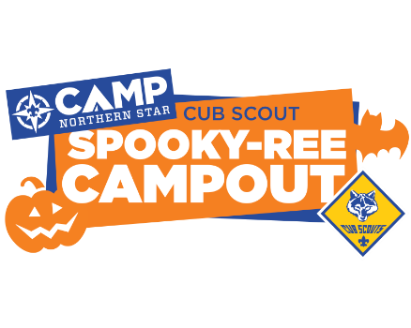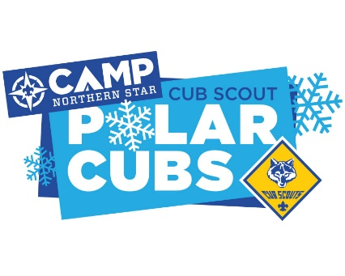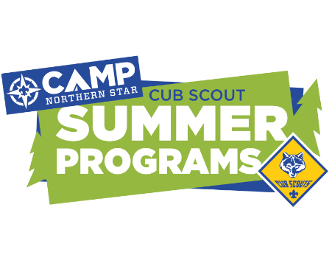

My Involvement as a Parent
Every Pack needs to have dedicated Adult volunteers to plan and run a great Pack program. Volunteers make sure that our Cub Scouts are able to enjoy and learn in the program.

In order to ensure we have enough volunteers, we ask that each family of a child volunteer to help run the Pack. These volunteer roles can be spread over the full year or focused on a key activity/time of the year. Some roles may be 4-5 hours per month, while others (like Fundraising or Pinewood Derby) may be 20-30 hours focused on 2-3 months.

At the Parent’s Meeting, we will be discussing open roles and needs to ensure your child benefits from the Cub Scouting Program

CUBMASTER & ASST CUBMASTER- Help plan and carry out the pack program with the help of the pack committee. MC’s monthly pack meeting, and attends pack leaders’ meeting and monthly roundtable meeting.

DEN LEADER(S) and ASST DEN LEADER(S)- Leads the den at den meetings and monthly pack meeting. They are encouraged to attend the monthly pack leaders’ meeting and roundtable meeting.

COMMITTEE CHAIR - Presides at all pack leaders’ meetings. Helps recruit adult leaders. Ensures the Pack is fulfilling its duty to the scouts and their families. Also helps lead the pack meeting and attends roundtable meetings.

SECRETARY – Take minutes of the Pack meeting and record key items such as things needing follow-up or items for the history of the pack. Maintain an inventory of pack property. Handle correspondence for the pack.

TREASURER - Keeps all records for the pack. Including pack bank account, financial records, etc. Attends pack meetings, pack committee meetings.

NEW MEMBER CO-ORDINATORS – Responsible for recruiting campaigns and for year-round recruitment, growth and retention for the Pack. Ensures a smooth transition of new Scouts into the unit and orientation for new parents.

ADVANCEMENT CHAIR - Maintains advancement records. Orders and obtains all badges and insignia. Attends pack meetings and pack committee meetings.

FUNDRAISING CHAIR – Supervise Fundraising and ensure that every youth member has the opportunity to participate in Pack fundraising activities and the annual Popcorn sales. This includes storing / managing the inventory, working with parents to provide more material for sales, tracking and returning unsold inventory.

FRIENDS OF SCOUTING (FOS) CHAIR – Friends of Scouting is the Council fundraising program that raises donations for Council Camps, facilities, and programming. The Chair attends the FOS training, organizes the FOS forms, arranges for the FOS presentations, and follows-up and track donations throughout the FOS campaign.

PINEWOOD DERBY CHAIR – Plans and organizes the Pinewood Derby for our Pack. Maintains the Pinewood Derby track and timing devices, organizes the race, recruits volunteers to run the track and timing, orders trophies, ensures a smooth Pinewood Derby for our Cub Scouts

PACK TRAINER - The Pack Trainer conducts, or facilitates, the training of leaders and parents in the pack. The pack trainer orients parents and leaders and guides pack leaders in carrying out their specific position responsibilities.

EVENTS CHAIR AND COMMITTEE – Plans and organizes the different activities, campouts, and volunteer opportunities our Pack organizes. Arrange for property, fire, and tour permits when required. Locate new picnic areas. Arrange for safe transportation when needed.

GENERAL – Do you have a special skill or talent? Check with your Den Leader or Cubmaster to see all the different ways you can help. The more help, the easier it is!

Learning about my Role - As a new parent, you may be wondering how you learn about your role and what is expected of you. Don’t Worry – there are lots of opportunities for training where you can get the basics and advanced training.

Youth Protection Training (online at www.My.Scouting.org ) – Every parent needs to complete Youth Protection Training if you have not yet done so

Position Training (online at www.My.Scouting.org ) – whatever role you have, the basic trainings are available online on a self-paced e-learning. These trainings give you the introduction to your role to help orientate you

Monthly Roundtables – On the first Thursday of the month, our District holds a meeting for all adult leaders and parents in the District. Roundtable gives you the opportunity to meet with other leaders in our area to learn tips, tricks, and best practices, as well as learn new ideas.

University of Scouting – Northern Star Council hosts a University of Scouting full-day training twice (2x) per year in October and April. Much like college, you register online for the advanced classes for your role.

Wood Badge – Scouting’s Advanced Training for all leaders is held over two weekends (Friday – Sunday). This training focuses on general leadership (useful for Scouts and professionally) and the overall aims and purposes of Scouting.

Uniform and Books
Look Sharp in your Uniform! The Cub Scout uniform identifies the organization within our community. We want our scouts to wear it properly and proudly. Our Pack has two approved uniforms for each member of the pack 1.) the Cub Scout Uniform (sometimes called a “Class A”) used during pack and den meetings or whenever a scout is representing our Pack and 2.) Our Pack T-Shirt (sometimes called a “Class B”) uniforms used during den and pack outings, such as hiking and camping (where the Cub Scouts are likely to get dirty).
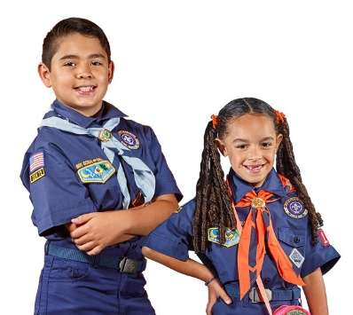
You can purchase the Cub Scout Uniform from the Scout Shop (http://www.northernstar.org/shop). The staff in the Scout Store can help you pick out the right items and below is a list by rank. There are also uniform exchange http://www.northernstar.org/about-uniform-exchange at the Northern Star Scouting Leadership Center that allows Scouts to buy, exchange, or donate good condition used uniforms.
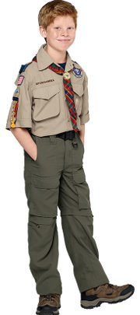
Note that Webelos may choose to continue to wear the Blue Cub Scout uniform or buy the Tan/Olive Boy Scout uniform. This choice is helpful for growing scouts or scouts with younger brothers. The Tan/Olive Boy Scout uniform is required when bridging to Scouts BSA.
NEW MEMBER CHECKLIST FOR THE BEST SCOUTING EXPERIENCE!
Our closest Scout Shop is in Plymouth: 10100 6th Avenue N, Ste 103, Plymouth, MN 55441
□ Blue Short Sleeve Shirt (buy it large for a growing Scout) | □ Cap (optional)
□ Patches: (Left Shoulder) Northern Star Scouting Patch, Pack Numbers  (Right Shoulder) Den # under flag  (Above Left Pocket) World Scout Crest Emblem | □ Blue Shorts / Pants / Skort or you can get a pair of ”Switchbacks” which is a combination of pants that convert to shorts or vice versa. (optional)
□ Neckerchief (Lion/Tiger / Wolf / Bear/Webelos) | □ Socks (optional)
□ Neckerchief Slide (Lion/Tiger / Wolf / Bear/Webelos)
□ Tiger or Cub Scout Belt (to hold belt loops!)
□ Handbook (Tiger / Wolf / Bear/ Webelos)

Sewing Uniform Patches
Cub Scout uniforms seem to have lots of patches! Kids love earning and displaying their rank advancement and showing off what activities they have done. Patches can be sewn on, either by you or by the Scout Shop, or can be glued on using Badge Magic (https://scoutingmagazine.org/2015/08/sponsored-spend-less-time-sewing-and-more-time-scouting/) Just be aware that Badge Magic can leave behind a residue if you remove / re-use the uniform with another Scout.

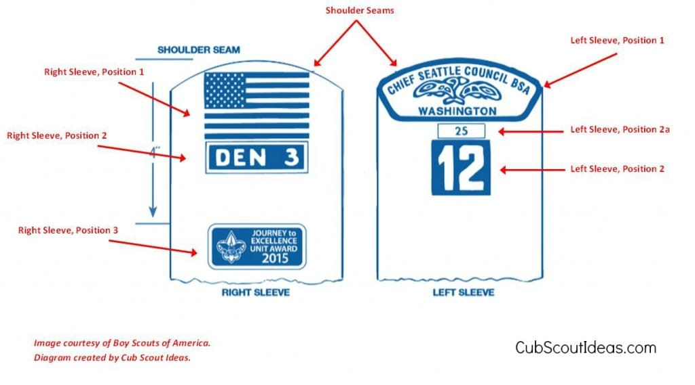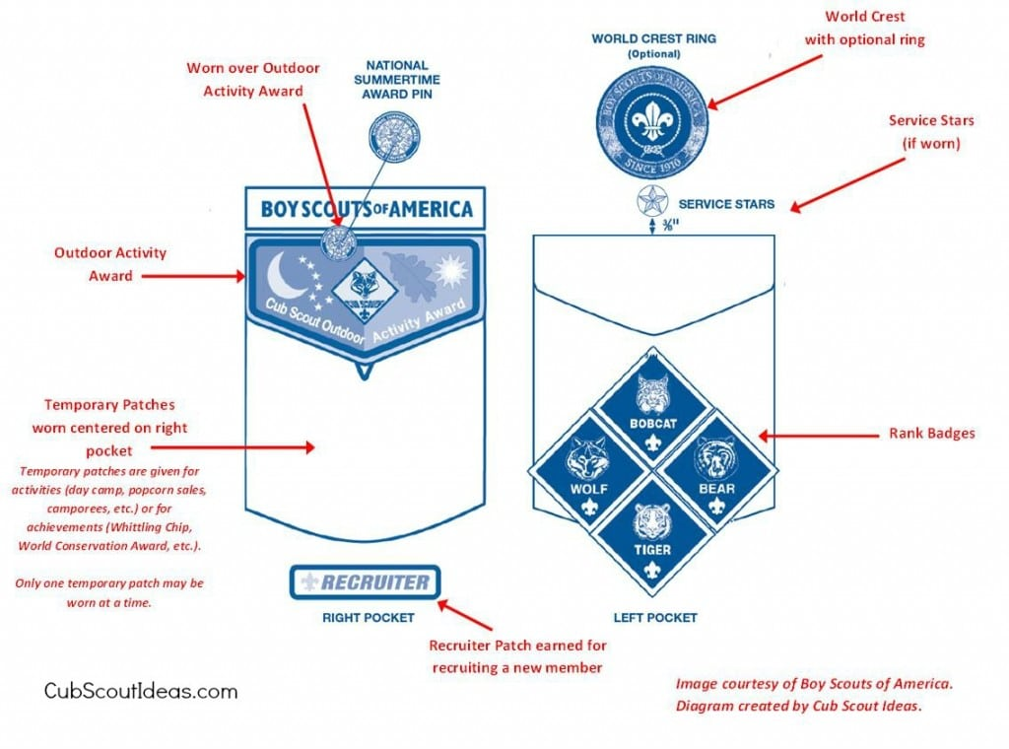
Key Information for my Scout

My Pack is:

Website Address:

My Pack Meets at:

My Pack meetings are on: Our monthly Pack meetings are listed on our website Event Calendar. Meetings are usually the 3rd or 4th Tuesday of the month

Pack xxx Cubmaster is: John Smith 612-999-9999 John.Smith@notarealemail.com
Pack xxx Committee Chair is: John Smith 612-999-9999 John.Smith@notarealemail.com

My Den is:
Grade | Rank | Den Leader | Den Leader Phone | Den Leader email
Kindergarten | Lion – Boys
Kindergarten | Lion – Girls
1st Grade | Tiger - Boys
1st Grade | Tiger - Girls
2nd Grade | Wolf – Boys
2nd Grade | Wolf – Girls
3rd Grade | Bear – Boys
3rd Grade | Bear – Girls
4th Grade | Webelos – Boys
4th Grade | Webelos – Girls
5th Grade | Arrow of Light – Boys
5th Grade | Arrow of Lights - Girls

My Den Meets on: ______________________________________________________

My Den Meets at:_______________________________________________________

