Lake Minnetonka

Fall Camporee 2019

INFORMATION PACKET

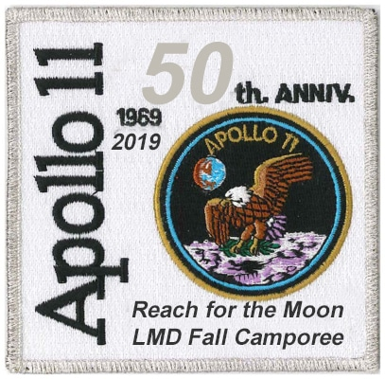
Reach for the Moon

Celebrating the 50th Anniversary of the Moon Landing
Friday through Sunday, October 11-13, 2019
Sibley County Fairgrounds, 801 W Chandler St, Arlington, MN 55307.
Neil Armstrong was an astronaut and aeronautical engineer who was the first person to walk on the Moon. He was also a naval aviator, test pilot, and university professor. But first, he was a Scout.
Neil Armstrong didn’t stop at the 21 merit badges required for Eagle – he finished with 26—including the Scholarship, Aviation, Pathfinding, and Pioneering Merit Badges. Unfortunately for Neil though, the Space Exploration merit badge wasn’t created until 1965—the year he turned 35.
Activities Include:
- Orienteering (including night orienteering)
- Rocket Build & Launch Contest
- Launch your Custom Rocket
- Styrofoam Glider Competition
- Paper Airplane races
- Merit Badges (all are partial)
  - Astronomy
  - Orienteering
  - Space Exploration
- Scout Skills Stations
- Tang Dessert Competition
- Campfire
- Camporee Patch!
Join us for a great camporee with a focus on exploring aerospace and outer space! There will be competitions, merit badges and more! Plus, we’ll have a dessert cook-off featuring astronaut’s favorite flavoring… TANG!! More details will be coming soon.
Thank you for your efforts to date and your commitment to putting on a great event for the youth in our district!

Price per Person – $15 (One price - all day Saturday or stay the weekend).

Check-in starts at 6:00PM Friday and the event runs through 9:00AM Sunday morning. All Scouts and their guests are invited. .

Many thanks to our host units Troops 3337, 3424, 5424, 5569 and the District Activities Staff for planning this event.

Sibley County Fairgrounds

Arlington, MN

Camporee Description
Come join your fellow Scouts BSA, Venturers, Webelos Scouts and their parents from the Lake Minnetonka District for our Fall 2019 Camporee at the Sibley County Fairgrounds.

In 1969, Eagle Scout Neil Armstrong landed on the moon. This year, we commemorate his accomplishment with a Reach for the Moon! Camporee. This is a great camporee with a focus on exploring aerospace and outer space!

There will be competitions, merit badges and more! Scouts, Venturers, and Webelos will have the chance to learn about aeronautics, space, and get hand’s-on experience. Attendees will also have the chance to build Scout Skills needed to earn First Class. Plus, we’ll have a dessert cook-off featuring every astronaut’s favorite flavoring… TANG!!

Location and Directions
Sibley County Fairgrounds, 801 W Chandler St, Arlington, MN 55307. Entrance to the Camporee is located at the corner of 9th Ave NW and W Chandler St in Arlington. Please see the maps and directions located on the camporee resource page http://www.lmdbsa.org/wintercamporee .
In July of 1885 the Sibley County Fair directors met to select a location to hold the fair for the next 5 years. The village of Arlington was selected and the fair was held there September 24-26. Prior to that it was in Henderson.

The City of Arlington donated $1,700 and grounds to keep the fair for the next 5 years. On the grounds, west of the Catholic Church, a half-mile track was built and buildings were constructed to house exhibits. The grounds were to be used for both the fair and also as a park.

Cost Per Person

$15.00 Saturday Activities only (no overnight)

$15.00 Tent Overnight + Saturday Activities - over night tent camping either Friday or

Saturday, or both nights. includes Saturday Activities

General Information

Attendance All Lake Minnetonka ScoutsBSA , Venturer, and Webelos Scouts and their parents, are invited to participate.

Check-in Friday evening beginning at 5:00PM, or Saturday morning 8:00-8:45AM see the ‘Schedule of Events’ below. Registration must be made online. No on-site registrations will be available.

Tent campsites are assigned at check-in. Tent campsites do not have fire rings or picnic tables.

Camp Fees Included in the base fee.

Parking Fees Included in the base fee.

Meals Bring your own food and cooking equipment for all meals. Camping areas do not have fire rings or picnic tables. Water is available at the Headquarters.

ONLINE
Registration
Deadline Wednesday, October 9, 2019 @ 10am

Merit Badges Scouts can earn partial credit for the Astronomy, Orienteering, and Space Exploration. Bring Scoutmaster signed BLUE CARD.

- Print the Astronomy Merit Badge worksheet
http://www.lakeminnetonkadistrict.org/wp-content/uploads/2017/11/Astronomy.pdf

- Print the Orienteering Merit Badge worksheet
http://www.lakeminnetonkadistrict.org/wp-content/uploads/2017/11/Fishing.pdf

- Print the Space Exploration Badge worksheet
http://www.lakeminnetonkadistrict.org/wp-content/uploads/2017/11/Nature.pdf

Activities & Competitions Offered During Rotation (offered in all rotations unless noted)
- Astronomy Merit Badge (Rotation 3 only)
- Space Exploration Merit Badge (Rotation 1 & 2 only)
- Orienteering Merit Badge
- Orienteering Course
- Scout Skills – work on skills for Tenderfoot through 1st Class
- Styrofoam Glider – each unit will be provided one Styrofoam glider to complete for longest flight time
- Paper Airplane Contest
- 2-Liter Rocket Contest
- Build & Launch Contest – rockets will be provided for all Youth to build and compete on-site in a timed competition
- Launch your Custom Rocket – Patrols or Units can build their own custom rocket to be launched

Dessert We are looking for the best troop/crew/team Dutch oven dessert. See below for
Competition additional information, rules, and the judges’ form

Campfire program Your troop/ patrol/ crew is encouraged to do a skit or song at the Saturday night campfire
program.

1st Aid Please have the proper medical forms and permission slips handy for every Scout when you
check in. The medical form is found on the camporee resources page.

Fires No campfires or cooking fires are permitted at the campsite. Units should plan on using propane,
white gas, or other similar fuel stove for cooking. The only fire permitted will be the Saturday evening Camporee Campfire.

ScoutBSA Medical http://www.lmdbsa.org/wintercamporee

Webelos Medical http://www.lmdbsa.org/wintercamporee

Uniforms Scouts and leaders are expected to be in full uniform for all Saturday events and evening programs.

Bring 1. Bring your tents, shelters, sleeping bags, pads, food, stoves, cooking utensils, insulated containers, beverages, cups and silverware.

- Bring your Dutch oven for the dessert cooking contest. See the “Dessert Cooking Contest” rules found below.

- Bring your own rocket for the Launch your Custom Rocket

- Bring 2-Liter Bottles and materials for your Bottle Rocket Launch

Parking Parking for your vehicle and trailer is available. See the “Map of Sibley Fairgrounds” for parking locations on the camporee resources page

Patch

Camporee Policies

The following rules were made to help us have a successful and safe camping experience. It is the responsibility of the adults in charge to see that Scouts know and understand these rules. Anyone violating them may be asked to leave the camp.

Behavior: Scout Oath and Scout Law – applies to all Scouts and Scouters. Please emphasize the “good sport” and “do your best” aspects of Scouting. First and foremost, we’re here to have fun.

Vehicles: Speed limit is 15 mph. No passengers in back of truck or trailer. Vehicles are limited to main roads and parking areas only. Trailers, if brought, must stay with vehicle parking in designated parking areas.

Firearms: Personal firearms, ammunition (live or expended), explosives, fireworks and toy weaponry are prohibited.

Conservation: Please conserve our natural resources. No cutting of brush or standing timber is allowed. Firewood will be provided.

Adults: At least one responsible adult (21 or older) must be in camp at all times.

Knives: NO straight-bladed knives are allowed in camp.

Lights out: Scouts are not allowed out of their site after lights-out with the exception of to-and-from the latrines. Please respect others during lights-out. Scouters are asked to bring roaming Scouts to the headquarters at Shelter B after lights-out.

Radios: No radios, stereos, tape players, headsets, Game boys or related electronics, etc. are allowed in camp. Cell phone use by youth should be kept to a minimum.

Registration of Units Outside of Lake Minnetonka District: Registration is open to units outside Lake Minnetonka District.

Refund Policy: Refunds will be made at the discretion of the event chairman.

Schedule of Events

Friday

5:00 - 8:00 Check-in and set-up camp
8:00- 8:30 Cracker-barrel for Staff, SPLs and SMs at HQ
Get Schedule changes and details
8:30 – 10:30 Movie Night (Apollo-themed movie) at the Heritage Building
11:00 Taps/Lights-out

Saturday

7:00 Reveille
7:00 - 9:00 Breakfast and clean-up
8:00 - 8:45 Check-in for Saturday-only participants
8:30 Staff Briefing in HQ
9:00 Flag raising at HQ
9:15 - 11:30 Activity & competition rotation (rotation 1)
12:00 - 1:00 Lunch – (Troops turn in skits and songs to the OA team
for campfire program)
1:00 - 3:00 Activity & competition rotation (rotation 2)
3:00 - 5:30 Activity & competition rotation (rotation 3)
5:30 Colors retired
5:30 - 6:30 Meal Preparation
6:30 - 8:00 Dinner and Clean-up
7:00 - 7:30 Dessert competition judging in HQ
8:00 - 9:00 Campfire Program and Awards
9:30 Troop reflections
9:30 Astronomy merit badge - Sky Watch
10:00 Taps/Lights-out

Sunday

7:00 Reveille
7:00 - 8:00 Breakfast and clean-up
8:30 - 9:30 Break camp, clean-up and checkout

Registration online: https://scoutingevent.com/250-lm2019fallcamporee

Camporee Scholarships
Scholarships are available for Scout families in need. Unit leaders, please contact
Your requests will remain confidential.

REMEMBER THE BUDDY SYSTEM AND BE SAFE AT ALL TIMES.
HAVE FUN! “SCOUTING IS A GAME WITH A PURPOSE.”

Evaluation for the Youth to turn in at checkout

Question 1: Please evaluate. (Circle one)

Much better somewhat better somewhat worse Worse
Than expected than expected Expected Than expected then expected
Info available before event o o o o o

Program o o o o o

Facility o o o o o

Comments __________________________________________________________________________________________

Question 2: Things we liked about this camporee_________________________________________________
____________________________________________________________________________________________________________________________________________________________________________________

Question 3: Things we didn’t like about this camporee ___________________________________________
____________________________________________________________________________________________________________________________________________________________________________________

Questions 4: If your unit was a host troop/unit please rate your experience? (Circle one)

Much better somewhat better somewhat worse Worse
Than expected than expected Expected Than expected then expected
Meetings and Info
available before event o o o o o

Tasks assigned to us o o o o o

Expectations of our unit
the weekend of the event o o o o o

Communications from district o o o o o

What could be done to enhance the Host Troop experience? _______________________________________
_______________________________________________________________________________________

Question 5: Do you have any ideas for future camporees?_________________________________________
________________________________________________________________________________________ ________________________________________________________________________________________

Please turn in at checkout. Thanks for your comments.

Dessert Cooking Competition

Your dessert must be prepared on-site on Saturday, October 12
You may any other outdoor preparation method. Good Luck!

Grading Criteria

- Plate Presentation

A.Overall Taste (flavor) ____/25

B. Texture* ____/20

C. Plate Layout / Space Ingredient* ____/20
Total ____/65

Scout Presentation

A. Clean Hands/Fingernails ____/10
B. Uniform* ____/10
C. Pride/Scout Spirit / Story* ____/10
D. Recipes (typed neatly/easy to read) ____/5

Total ____/35

Grand Total ____/100
Comments:

*Definitions:
Texture – Mouth feel. Is it mushy when it should be firm (for example, in a stew a carrot should be “al dente” or firm to the bite and the carrot should not be mushy).

Plate Layout – Eye appeal. Are there a variety of different colors or is there one color that overpowers all the other colors on the plate? There should be a variety of different colors. Does it look appetizing? How does it use the TANG ingredient (be creative!)

Your Uniform – Is it tucked in (neatly), CLEAN, Neck wear (neckerchief/bolo tie).

Campsite Inspection Form Troop_________________
An organized and safe campsite is the key in surviving the outdoors. Troop campsites will be judged on the following criteria:

- Campsite Identification (15 points)
______American Flag
______Troop Flag
______Gateway with troop sign

Campsite and sleeping arrangements (20 points)
______Tents pitched by patrol
______Campsite neat and orderly

Health, safety and sanitation (30 points)
______Cooking area clean
______Dishes washed and put away
______Food properly stored
______Garbage picked up

______First aid kit easily seen

______Fire plan posted
______Fuels properly stored

______Wood tools properly stored

Menu planning, Duty roster (15 points)
______Menu for all meals
______Duty roster posted

Campsite Improvement (5 pts each)

______Campsite improvements made by Scouts (lashings, etc). Examples include a built utensil rack, pack rack, table, seat, fire bucket holder, wash bin holder,

Camporee Theme (up to 20 pts)

______Campsite and/or Scouts are tied to the Camporee Theme. Examples includes: custom gateway, Scouts in costume, patrol camping area names, Menu names, duty roster names

Competition Rules

Rocket Build & Launch Contest – Rockets will be provided to each youth participant. Rockets must be built using the materials (tube, fins, etc) that are provided in the work area. No extra fins, motors, etc may be used in building the rocket. Participants will have exactly 15 minutes to build the rocket from the starting whistle – late arrivals will not have additional time.

Launching – participants will be launched at one of the launching stations provided by the camporee staff

Judging – contestants will be judged based on total flight time, as observed by the launch staff. Total flight time is from ignition to ground hit /visible loss of sight. In the event a rocket does not launch, explodes, or otherwise does not sustain flight, the participant is disqualified

Styrofoam Glider Competition – 1 Styrofoam Glider of (xxxx model) will be provided to each unit for competition. Gliders will be provided Saturday morning. Participants can modify the Glider in any safe manner other than adding powered flight (no motors, rockets, etc). Winners will be judged on greatest flight time.

Paper Airplane races – Participants must use an 8.5”x11” sheet of 20lb paper (provided). Any method of folding, etc is permitted. Airplances must be launched by hand and cannot be powered (no motors, rockets, etc). Winners will be judged on greatest flight time.

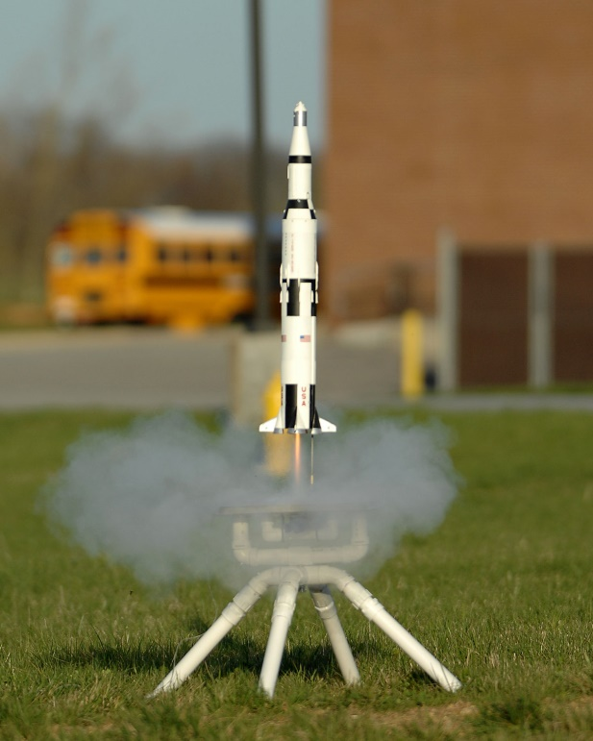
Launch your Custom Rocket
Have you ever build, launched, and recovered a model rocket? Rocketry is a fun, exciting activity for Patrols and Troops. At Fall Camporee, your Patrol can compete for the BEST CUSTOM ROCKET!

Patrols or Units who will to compete in the Custom Rock Launch will be able to build and enter a custom rocket (C or smaller motor). Rockets should be prepared prior to the Camporee.
Participants should bring their own rocket launch pad/system (unless you decide not to launch).

The rocket should be built prior to arrival at the launch site and Scouts must provide their own appropriate class A, B, or C rocket engine.

Judging Criteria
- Rocket Presentation

Overall Rocket Appearance ____/20

B. Innovation Design / Complexity ____/20

C. Total Flight Time ____/35
1 pt for each second of flight above 45 seconds
Total ____/75

Scout Presentation

A. Clean Hands/Fingernails ____/10
B. Uniform* ____/10
C. Pride/Scout Spirit / Story* ____/10
D. Photos/Display(typed neatly/easy to read) ____/5

Rocket Launch Safety Rules
Remember that only adults are allowed to handle the engines. Ensure that you review the rocket kit instructions and select the recommended engine size. Watch this video for a very good briefing on prepping rockets prior to launch: https://youtu.be/hC6evC1N05c.

Rocket Launch Safety The safety of our youth, volunteers, staff, and employees is an important part of the Scouting experience. Only adults are allowed to handle or load rocket motors. Adults should always closely supervise ALL rocketry building, launching, and recovery activities.

National Association of Rocketry (NAR) Safety Code and other safety guidelines will be followed:
- Launch safety – countdowns, 15-foot safety circle
- Launchers – End of launch rod must be above eye level.
- Motors. I will use only certified, commercially-made model rocket motors, and will not tamper with these motors or use them for any purposes except those recommended by the manufacturer.

- Launch site – 400-foot open area required for a type C engine; monitor wind and dry grass conditions
- Every rocket should be safety inspected prior to launch.
- If a rocket misfires or does not launch, be sure to wait a minimum of 60 seconds before approaching it.
- Lightning, winds, or any adverse weather should immediately stop the launch.
- Recovery safety – Do not attempt recovery from power lines, tall trees, etc.
- In case of inclement weather, the launch will be rescheduled. BSA Guide to Safe Scouting policies must be followed.

