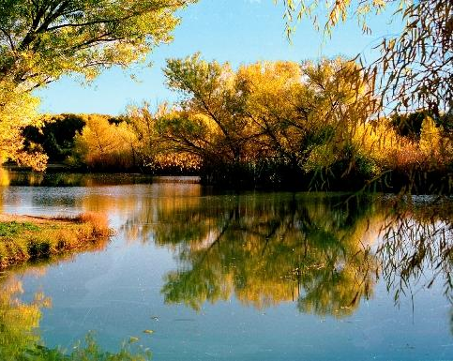
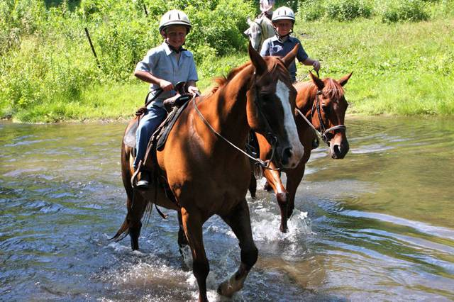
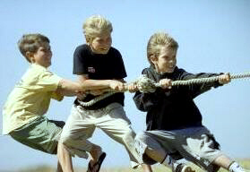
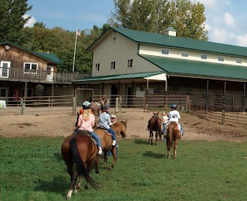
Lake Minnetonka District
Fall Camporee 2018
Horse Ranch Campout

Informational Packet

October 12-14, 2018
Carver County, Minnesota

Come join your fellow Boy Scouts, Venturers, Webelos, AND Bear Scouts from the Lake Minnetonka District for our Fall Camporee 2018 at the River Valley Ranch, October 12 - 14, 2018.
Located on 480 private acres in Carver, Minnesota on the shores of the beautiful Minnesota River, this location is fantastic! There are dense woods, open fields, and secluded areas. In fact, it is considered one of the best trail ride locations in the Twin Cities!
Price per Person – $15.00 plus an optional $25.00 for a horseback trail ride

One-hour horseback trail rides
- Merit Badges* (Horsemanship – Sally’s father)
  - Horsemanship o Wilderness Survival (please ask Julie)
  - Metalwork (?) o Fishing (with the US Fish and Wildlife Service)
- Webelos Adventure Pins* (Please ask Sally- Mellissa?)
  - Outdoorsman o Webelos Walkabout o Cast Iron Chef
  - Castaway o Into the Woods o Into the Wild
- Bear Adventure Belt Loops* (Please ask Sally- Mellissa?)
  - Bear Necessities o A Bear Goes Fishing
  - Bear Picnic Basket o Fur, Feathers, and Ferns
- Unit competitions - including a Western Cooking Contest
- Climbing Wall
- Campfire program
- Camporee patch
- Service project
- Webelos and Bear Advancement

This will be a fantastic event you won’t want to miss!

We will continue with our popular carnival atmosphere where you can take advantage of preplanned activities, or create your own program and have some downtime. This is a western-themed event, so dress and cook appropriately. In other words, cowboy hats, boots, and lots of beans in the Dutch oven is expected and appreciated.

Invite your Webelos!
Many thanks to our host units T174 T303, T330, T409, T589, T702, Jim Lindfors, Brett Schneider, Brian Klein, David Olson, and the Activities Committee for working on this Camporee.

* Scouts may earn partial credit for the merit badges and adventure loops/pins offered at this camporee.

Registration and Additional Information http://www.lmdbsa.org/2018FallCamporee

Contacts
Scott Janke
Scott.Janke@lmdbsa.org

Daron Meyer
Daron.Meyer@lmdbsa.org

Mellissa Stanfa-Brew
Stanfabrew@lmdbsa.org

Jim Lindfords
Jim.Lindfords@lmdbsa.org


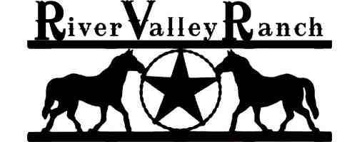

Carver County, Minnesota

Camporee Description

Come join your fellow Boy Scouts, Ventures, Webelos, and Bear Scouts from the Lake Minnetonka District for our Fall Camporee 2018 at the River Valley Ranch, October 12-14, 2014.

Venue - Located on 480 private acres in Carver, Minnesota on the shores of the beautiful Minnesota River. This location is fantastic! There are dense woods, open fields, and secluded areas. In fact, it is considered one of the best trail ride locations in the Twin Cities!

Create Your Own Unit Activities – We are once again using our popular carnival atmosphere format. What that means is each unit is allowed the flexibility of choosing from the activities provided by the district and/or running their own specific activities. In other words, a unit can schedule a trail ride and blacksmith activity and/ or run your own unit activity such as fishing, hiking, or orienteering. The possibilities are almost endless.

Merit Badge Opportunities - Partial credit will be given for the following merit badges: Metalwork, Wilderness Survival, Horsemanship, and Fishing. Please have your Scouts bring a filled out blue card. Those working on Metalwork Merit Badge should bring food-grade metal cans for their metalwork project. Anyone working on Fishing Merit Badge should plan on bringing their personal tackle, bait, and pole.

Hiking/ Backpacking - There are miles and miles of trails (get that 10-miler done).

Programming and Activities - Program and activities will include a one-hour horseback trail ride, the campfire program, unit competitions such as western-themed cast iron cooking contest, field games, the climbing tower, and best campsite. There will be a service project as part of the activities rotation.

Wilderness Survival - Build a shelter and sleep in the woods.

Webelos and Bears - Webelos and Bears are absolutely encouraged to attend. They can participate in all activities and competitions.
Adventure Loops/ Pins Opportunities - Many of the requirements for adventures can be completed at the camporee through planned activities, with your unit, and/or during preparation for this camporee. Consider working on any or all of the following:

Webelos Adventure Pins: Outdoorsman; Webelos Walkabout; Cast Iron Chef; Castaway;
Into the Woods; Into the Wild

Bear Adventure Belt Loops: Bear Necessities; Bear Picnic Basket; Fur, Feathers, and Ferns;
A Bear Goes Fishing (bringing your own tackle, bait, and pole)

Webelos/ Bears are encouraged to attend with a parent. Webelos may attend as part of a Troop and work on their Scouting Adventure Pin. Webelos/ Bears and their parents are welcome to stay the night(s) with a parent or just spend the day on Saturday participating in the camporee events.

Those Webelos who would like spend the night with a parent are in encouraged to make arrangements to camp with a Troop, or contact Scott.Janke@lmdbsa.org and he will locate a Troop for you.
It will be a fantastic event that you won’t want to miss!
Theme - This is a western-themed event, so dress and cook appropriately. In other words, wear your cowboy hats and boots (no side arms please*) and the use of lots of beans in the Dutch oven is expected and appreciated.

*Pursuant Scout policy, Scouts are not to include replica firearms in their Western-themed outfits.

Location and Directions

River Valley Ranch - 16480 Jonathan Carver Parkway, Carver, Minnesota.
Please see the camporee maps and driving directions located on the camporee
resources page http://www.lmdbsa.org/2018FallCamporee .

Directions Take MN Highway 169 South to Jordan, MN.
Turn right at the stoplight County Road 9.
Go 2.5 miles and take a left into the River Valley Ranch Driveway.
Watch for signs

Cost Per Person

$25.00 One - Hour Trail Ride (optional) Adults should not plan to ride. However, if there are empty spots,
adults may pay the ranch directly and ride with the Scouts.
$15.00 Tent Overnight + Saturday Activities Overnight Bring Your Own Tent Camping either Friday or
Saturday or both. Includes Saturday Activities, all programs and events, merit badge and adventure loop/pin offerings, and camporee patch (trail ride extra
$15.00 Saturday Activities Includes Saturday Activities, all programs and events, merit badge and
adventure loop/pin offerings, and camporee patch (trail ride extra).

Units Attending From Other Districts

Units from other districts are welcome to attend. The only limitation would be the one-hour trail ride. Units will be able to participate in all other actives and programs. We have a limited
number of trail-rides available and we will give priority to Lake Minnetonka District Scouts/ Venturers.
The chances are good, but not guaranteed, that your Scouts/ Venturers will be able to participate in
the one-hour trail ride.

Please register to attend the camporee. However, the registration system will not allow you to
purchase the trail-ride portion of your registration until September 22, 2018. At that time you will be
able to register for the trail-ride, if there are any open spots left.

General Information

Attendance All Boys Scouts, Venture, Webelos and Bear Cub Scouts and their parents are invited to participate.

Check-in Upon arrival either Friday evening, or Saturday morning. Pre-registration is mandatory through the online registration process. No on-site registration is available.

One adult leader (i.e., Scoutmaster) and one youth leader (i.e., SPL) should check-in your entire unit at one time. (T303 parking set up camp)

At check-in, you will be asked to provide:
- The Unit Attendance Form (attached to this Informational Packet) with the names of all Scouts and adults planning to participate in the program and your patrols.
- All medical forms for each participant must be kept on-site, secure, and accessible.
- A list and time of visitors (non-Scouters) visiting camp.
- The time you plan to check out, so we can inspect your campsite.

Once you have been checked-in, you will be directed to your designated camping area.

Every effort will be made to assign your unit to a campsite appropriate for the size of your unit. We ask that you set up your campsite in the area designated for you. We have planned the locations of our program areas to minimize the amount of traffic through your camping areas and to avoid having distractions too near to the program areas.

Cold/Rain weather tips are available on the ccamporee rresources page at the website
http://www.lmdbsa.org/2018FallCamporee . We encourage adults to take the new
Hazardous Weather training module at https://my.scouting.org.

Camping Options Please designate your preference during the registration process
- In field with vehicle access
- Pack in, ½ mile hike to field, location by river
Note: Camping is rugged. There will be no picnic tables at either location. Please
remember to bring the appropriate gear. See the camporee maps posted on the
camporee resources page for additional information:
http://www.lmdbsa.org/2018FallCamporee .

Trail Ride Release All Scouts must provide the district with a signed copy of the Trail Ride Release of
Of Liability Liability Form (attached to this information packet), at the Cracker Barrel
Form at 9:00pm on Friday night. Without a signed form, the Scout will not be issued a
wristband and will not be allowed to ride a horse.

Camp Fees Included in the base fee.

Parking Fees Included in the base fee.

Meals Bring your own food and cooking equipment for all meals. There is a water spigot within walking distance of each campsite. Be prepared to carry your water to your campsite. Or bring water with you to the camporee.
ONLINE
Registration http://www.lmdbsa.org/2018FallCamporee
Deadline October 8, 2018 at 11:55pm

Merit Badges Scouts can earn partial credit for the Horsemanship, Metalwork, Fishing,
and Wilderness Survival Merit Badges. Please have your Scouts bring a filled out blue card. Remember: Metalwork participants should plan on bringing a food-grade can, and those participating in the Fishing course should bring their own equipment.

- Print the Horsemanship Merit Badge workbook
http://www.lmdbsa.org/wp-content/uploads/2018/04/Horsemanship.pdf

- Print the Fishing Merit Badge workbook
http://www.lmdbsa.org/wp-content/uploads/2017/11/Fishing.pdf

- Print the Metalwork Merit Badge workbook
http://www.lmdbsa.org/wp-content/uploads/2018/04/Metalwork.pdf

- Print the Wilderness Survival Merit Badge workbook
http://www.lmdbsa.org/wp-content/uploads/2017/11/Wilderness-Survival.pdf

Webelos/ AOL Pins Webelos can earn portions of the Webelos/Arrow of Light Adventure Pins through planned activities, with your unit, and/or during preparation for this camporee
(Please ask Sally- Mellissa?)

- Outdoorsman worksheet – Spend the night!
http://meritbadge.org/wiki/images/e/ee/AOL_Outdoorsman.pdf

- Webelos Walkabout worksheet – Plan a 3 mile hike around the grounds!
http://meritbadge.org/wiki/images/4/44/Webelos_Walkabout.pdf

- Cast Iron Chef worksheet
http://meritbadge.org/wiki/images/a/a2/Cast_Iron_Chef.pdf

- Castaway worksheet – Participate in the wilderness survival merit badge session!
http://meritbadge.org/wiki/images/c/cf/Castaway.pdf

- Into the Woods worksheet
https://meritbadge.org/wiki/images/0/01/Into_the_Woods.pdf

- Into the Wild worksheet
https://meritbadge.org/wiki/images/5/5c/Into_the_Wild.pdf

- Scouting Adventure worksheet https://meritbadge.org/wiki/images/a/a8/Scouting_Adventure.pdf

Bear Adventure Bears can earn portions of Adventure Belt Loops through planned activities, with your Loops unit, and/or during preparation for this camporee. Bears participating in fishing should
bring their own equipment. (Please ask Sally- Mellissa?)

- Bear Necessities worksheet – Spend the Night!
http://meritbadge.org/wiki/images/0/07/Bear_Necessities.pdf

- Bear Picnic Basket worksheet – Participate in the cook off!
https://meritbadge.org/wiki/images/1/1a/Bear_Picnic_Basket.pdf

- Fur, Feathers, and Ferns worksheet
http://meritbadge.org/wiki/images/a/a3/Fur_Feathers_and_Ferns.pdf

- A Bear Goes Fishing worksheet – Participate in the fishing activities!
https://meritbadge.org/wiki/images/9/9f/A_Bear_Goes_Fishing.pdf

Activities Offered Units, patrols, dens, parents with Scouts, or individual Scouts may rotate though the
9:00AM – 5:30PM various activities, including merit badge opportunities, Webelos Pins, or Bear Adventure
Loops, except for the trail ride and blacksmithing. Your unit or group will be assigned
a time slot and receive an appropriate wristband for these two activities.

District Planned Events and Activities

- Horse trail ride – Be at the trail ride 20 minutes prior to your scheduled time.
- Blacksmithing activities
- Climbing wall
- Fishing
- Merit badges
- Bear Adventure Loops
- Webelos Adventure Pins
- Field games
- Best Campsite Competition (form attached)
- Cast Iron Cook-Off

Cast Iron Western We are looking for the best ‘cast iron’ (Dutch oven) entrée or dessert by a troop, crew,
Cooking or team. See the Cast Iron Western Cooking Competition Rules below for additional
Competition information. You must register online at http://www.lmdbsa.org/2018FallCamporee.
There will be special guest judges (the trail ride ranch hands) to grade not only your plate presentation but also the Scouts' presentation. Winning unit received 14” Dutch Oven (T174)

Campfire Program Your troop, patrol, crew, or den is encouraged to do a skit or song at
the Saturday night campfire program. Please have your skit approved
by your Cubmaster, Scoutmaster, or Advisor.

First Aid Please have the proper medical forms and permission slips handy for
every Scout when you check in. The medical form is found on the
camporee resources page (link below).

Medical Forms Please have the proper medical forms and permission slips handy for everyone when
you check in. The BSA Annual Health and Medical Record form (Parts A & B required) is found at http://www.lmdbsa.org/2018FallCamporee . Youth as well as Adult Leaders are
required to complete the BSA medical form, sections A and B.

Campfires Campfires are allowed, however, you will need to collect your own downed fire wood from the woods, and build your own fire ring. No cutting of live trees is allowed. You will need saws and axes. Please follow all BSA rules on fire-building and tool usage. All wood gathered must be burned prior to departure.

Water There is a water spigot within walking distance of each campsite. Be prepared to carry your water to your campsite OR bring water with you to the camporee.

Uniforms Scouts and adult leaders should be in activity uniforms (class B) for Saturday events and activities. Scouts and adult leaders are expected to dress in field uniform (class A) for travel, for your cooking competition presentation, as well as the Scout’s Own Service on Sunday.

Bring 1. Bring your medical form, trail ride permission slip, blue cards (as needed), tent,
sleeping bag, sleeping mat (optional), personal clothing/gear, camp/sports chair,
cookware, stoves, plates, cups, utensils, dish washing equipment, trash bag, hiking
boots, walking shoes, work gloves, fishing gear (if fishing), non-perishable food items
for donation (optional), and dress for the weather. Remember to bring your food for
your meals.

- Bring your recipes, ingredients, and any cooking equipment for the western themed cast iron cooking competition. See ‘Cast Iron Western Cooking Competition’ above for additional information.

- If there is any chance you will be horseback riding, bring: your Trail Ride Release of Liability Form, long pants, closed toed shoes (with a heel, if possible), and an equestrian or bicycle helmet.

Parking Parking for your vehicle and trailer is available. Trailers and vehicles may be parked at
your campsite, but all vehicles are expected to remain parked throughout the weekend. If
the vehicle must be used, do not park near the campsite. We do not want vehicles
moving though the campsite. See the camporee maps posted on the camporee
resources page for additional information: http://www.lmdbsa.org/2018FallCamporee .

Service Project The Order of the Arrow is sponsoring this service project. Please bring non-perishable
food items to be turned in at check-in Friday night. During the activities rotation period,
one of the activities will be a service project.

Campground Please be respectful of your campsite and remember ‘Leave No Trace’. Bring plastic
bags; all garbage is to be packed out.

Color Coded Wristbands will be provided at Cracker Barrel. The wristbands indicate if a Trail Ride
Wristbands Release of Liability Form (provided below) was received by the district. The color
of the wristband indicates the time period of the trail ride and blacksmithing. Without a
wristband, Scouts will not be able to ride a horse.

Camporee Patch A Fall Camporee 2018 patch will be provided in your check-in packet.

Camporee Policies

The following rules were made to help us have a successful and safe camping experience. It is the responsibility of the adults in charge to see that Scouts know and understand these rules. Anyone violating them may be asked to leave the camp.

Behavior: Scout Oath and Scout Law – applies to all Scouts and Scouters. Please emphasize the “good sport” and “do your best” aspects of Scouting. First and foremost, we’re here to have fun.

Vehicles: Speed limit is 10 mph. No passengers in back of truck or trailer. Vehicles are limited to main roads and parking areas only. For information regarding parking, please see the section above titled ‘Parking’.

Firearms: Personal firearms, ammunition (live or expended), explosives, fireworks, and toy weaponry are prohibited.

Adults: At least one responsible adult (21 or older) must be in camp at all times. You must observe the BSA Leadership Requirements of “two-deep leadership” and the youth/adult ratios, which can be found on the camporee page at http://www.lmdbsa.org/2018FallCamporee . For Webelos/ Bears: each Webelos/ Bear Scout at the camporee must be accompanied by a parent or guardian (a 1:1 ratio). It is recommended that all adults take the updated BSA Youth Protection Training (YPT) at https://my.scouting.org/.

Knives: NO straight-bladed knives are allowed in camp.

Lights out: Scouts are not allowed out of their campsite after lights-out with the exception of to-and-from the latrines. Please respect others during lights-out. Scouters are asked to bring roaming Scouts to the headquarters after lights-out.

Radios: No radios. Use of electronics should be kept to a minimum.

Registration of Units Outside of Lake Minnetonka District: Please see the section ‘Units Attending from Other Districts’ above. Registration for all Districts closes October 8, 2018 at 11:55pm.

Refund Policy: Refunds will be made at the discretion of the event chairman.

Registration online:
http://www.lmdbsa.org/2018FallCamporee
Send a Scout in Need to Camporee
Scholarships are available for Scout families in need. Unit leaders, please contact
Scott Janke Scott.Janke@lmdbsa.org
Your requests will remain confidential.

REMEMBER THE BUDDY SYSTEM AND BE SAFE AT ALL TIMES.
HAVE FUN! “SCOUTING IS A GAME WITH A PURPOSE.”

Saturday Activities

Groups Trail Ride and Activities Rotation – Units, patrols, dens, parents with Scouts, or
Individual Scouts may rotate though the various activities, including merit badge
opportunities, Webelos Adventure Pins, or Bear Adventure Loops, except for the trail
ride and blacksmithing. Your unit or group will be assigned a time slot and receive an
appropriate wristband at cracker barrel for these two activities. Remember
to plan for lunch!

Please see the camporee maps posted on the camporee resources page for additional
information: http://www.lmdbsa.org/2018FallCamporee .

Schedule of Events
Friday
5:00 - 8:00 Camporee Check-in and set-up camp (T303 Parking set up camp)
9:00 Cracker Barrel for Staff, SPL’s and SM’s AND Check-in for trail
ride and blacksmithing - hand in trail ride waivers and pick up
wristbands (district staff
10:00 Taps/Lights Out

Saturday
7:00 Reveille
7:00 - 8:30 Breakfast at your camp
8:00 - 8:30 Check-in for units arriving Saturday - Check-in for trail
ride and blacksmithing - hand in trail ride waivers and pick up
wristbands (district)
8:30 Flag raising, divide into groups, staff briefing (T489)
9:00 - 5:30 Trail Rides/ Activities Rotation/ Merit Badges – (plan time for your lunch)
(be at the Trail Ride 20 minutes prior to your scheduled trail ride time)
5:30 - 6:00 Retire Colors (T489)
6:15 - 6:30 Cast Iron Cook-Off Awards (Ranch hands judges) (T174)
6:30 - 8:00 Dinner- Units cook and eat at camp sites (free time)
7:30 - 8:30 Horse Merit Badge Presentation
8:45 - 9:30 Campfire Program/ Vespers/ Handout survey (T409? OA build fire?)
10:00 Taps/ Lights-out

Sat. Webelos
Prior to 8:00 Pack gear if you have a Saturday departure
8:45 - 9:30 Campfire Program and Vespers
10:00 Taps/Lights-out

Sunday
7:00 Reveille
7:00 - 8:00 Breakfast
8:30 - 9:00 Chapel or Scout’s Own Service ????
9:00 Closing at HQ for Staff, SPL’s and SM’s
9:00 Break camp and check-out with HQ

Note to self- do we need start times for MB, loop, and pin classes?
Trail Ride Release of Liability Form

Adult unit leaders must provide a signed copy of the Trail Ride Release of Liability Form for their Scouts, and
anyone else, at the Cracker Barrel on Friday evening or at Check-in for those people arriving on
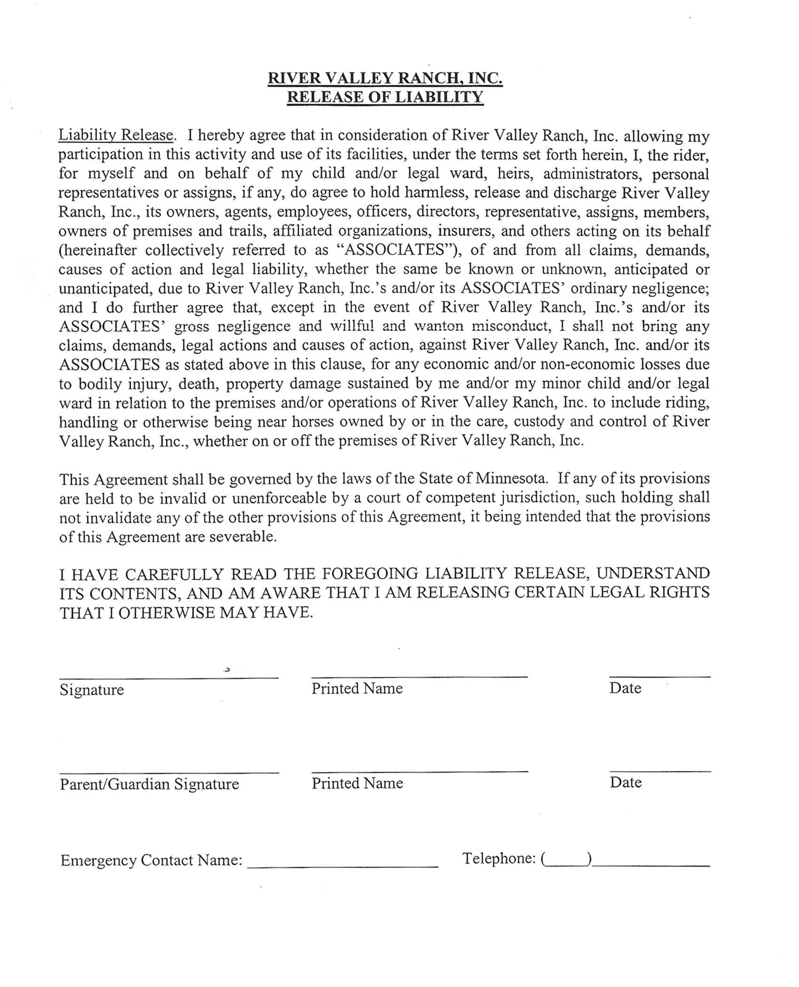
Saturday. Without a signed form, the individuals will not be issued a wristband and will not be allowed to ride a
horse.

Cast Iron Western Cooking Competition Rules Unit ___________

(To be used by the judges.)

The entrée or desert must be prepared on-site Saturday 10/13/18. Scouts must use a Dutch Oven. We are looking for the best outdoor ‘cast iron’ entrée or dessert by a troop, pack, crew, or team. Good Luck!

Cooking Competition Grading Criteria

- Plate Presentation

Overall Taste (flavor) ____/25

B. Texture* ____/20

C. Plate Layout** ____/20

Total ____/65

Scout Presentation

A. Clean Hands/Fingernails ____/10

B. Pride/Scout Spirit*** ____/10

C. Recipes or oral presentation ____/10
(Neat & easy to read or presentation is easy to follow)

D. Uniform**** ____/5

Total ____/35

Grand Total ____/100

Comments:

*Texture – mouth feel, is it mushy when it should be firm, ex: in a stew a carrot should be “al dente” or firm to the bite and the carrot should not be mushy.
**Plate Layout – Eye appeal. Are there a variety of different colors or is there one color that overpowers all the other colors on the plate? There should be a variety of different colors. Does it look appetizing?
***Pride/Scout Spirit – Enthusiasm, excitement and positive, helpful attitude.
****Uniform – Tucked in (neatly), CLEAN, Neck wear (neckerchief/bolo tie).


Lake Minnetonka District
Fall Camporee 2018 – October 12-14

Unit Attendance Form – Registration is available online.

Please bring this form AND your health forms with you to the event.

DISTRICT (Circle one): Lake Minnetonka District Other District ___________________
UNIT (Circle one): Troop Crew Team NUMBER: ___________
Name (Scoutmaster/Crew Advisor/Team Advisor): ________________________________________________
Name (SPL/Crew President/Team Captain): ________________________________________________
Name (of adult leader onsite at all times): _____________________________________________________________
Cell Phone: (of adult leader on site at all times): _____________________________________________
Where will medical forms be kept while at camp?_____________________________________
Note: Annual Health and Medical Record forms (Parts A & B) are required. Please bring one for every person attending the camporee. If you do not have forms, you may print them at http://www.lmdbsa.org/2018SpringCamporee. Do not mail in the forms. Bring the health forms with you to check-in and review the forms with the staff. Health forms are to be stored with the unit.

Scout/ Venturer Youth + Adult Participants | Webelos/ Bears + Adult Participants
Enter Total # Attending: | Enter Total # Attending:

Youth Attending - First and Last Name Circle W or B if the Scout is a Webelos or Bear - (Please type or print)
1 | W or B | 12 | W or B
2 | W or B | 13 | W or B
3 | W or B | 14 | W or B
4 | W or B | 15 | W or B
5 | W or B | 16 | W or B
6 | W or B | 17 | W or B
7 | W or B | 18 | W or B
8 | W or B | 19 | W or B
9 | W or B | 20 | W or B
10 | W or B | 21 | W or B
11 | W or B | 22 | W or B

Adults Attending - First and Last Name (Please type or print)
1 | 4
2 | 5
3 | 6

Webelos/ Bear Parents - If you registered on your own, enter the names of your Webelos/ Bear above and complete the questions below:
My son(s) will be camping with Unit ________ My son(s) is/are registered with Pack_________
Name (of Webelos/ Bear parent or guardian attending): ____________________________________________________
Cell Phone Number (of parent or guardian on-site at all times): ___________________________________
Where will medical forms be kept while at camp? ____________________________________

- Youth/Adult Ratio – Two-deep Leadership – Please review at http://www.lmdbsa.org/2018SpringCamporee
Contact David.Olson@lmdbsa.org

Campsite Inspection Criteria Unit__________
(to be used by inspectors during Fall Camporee 2018) (OA)

An organized and safe campsite is the key in surviving the outdoors. Troop campsites will be judged on the following criteria:

Campsite Identification
______American Flag
______Troop Flag
______Entryway with troop sign
Campsite and sleeping arrangements
______Tents or Quinsy’ pitched by patrol
______Campsite neat and orderly
Health, safety and sanitation
______Wood tools properly stored
______Garbage picked up
______Dishes washed and put away
______Cooking area clean
______First aid kit easily seen
______Fire attended or out, cold to touch
______Fire plan posted
______Fire located in proper area
______Fuels properly stored
______Food properly stored
Menu planning, Duty roster
______Menu for all meals
______Duty roster posted
Pioneering project
______Rated on amount of craft or detail to project
______Rated on utility or functionality
______Originality

River Valley Ranch – Fall Camporee 2018 - page 1 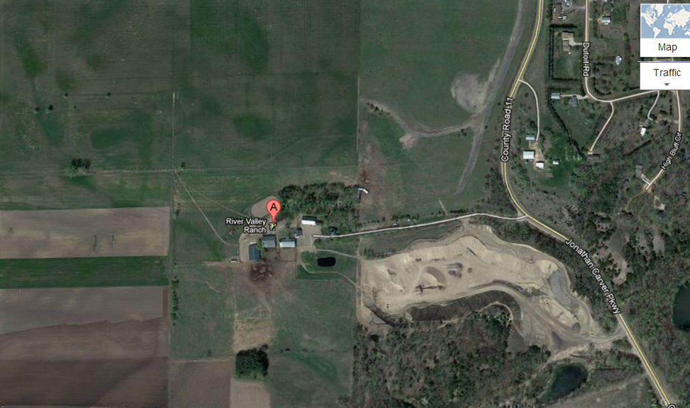
ENTRANCE TO CAMPING AREA Follow signs to check-in area, latrines available First Aid Station on Friday, Sunday, and during non-Saturday Activities

ENTRANCE TO RANCH Limited Parking - follow signs and continue to camping area
Field Games
Service Project Area:
(location to be determined)

River Valley Ranch – Fall Camporee 2018 - page 2

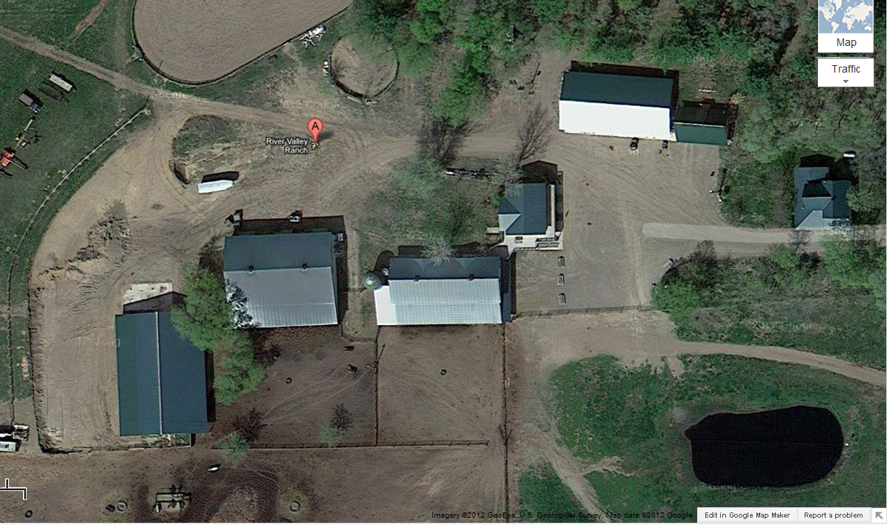
First Aid Station during Saturday Activities
Metalworking/ Blacksmithing
Latrines

Horsemanship Merit Badge

